Web UI components and advanced patterns

Elementary blocks of design

5 to 10 components make around 90% of design, reusable design

1. Images:

Avatars and Thumbnails

Buttons

Forms

Tabs/Navs

Navigation bars

Banners

Cards – on all index pages

Use Boris’s pre-done sample CSS stylesheet, loaded Bootstrap, googlefonts, fontawesome, placeholders for different elements.

Then we link all separate stylesheets for the various components to the main stylesheet.

via

@import url(“components/avatar.css”); , in the CSS main file, for example

Coding each web component on a separate stylesheet

1. Avatar:

HTML: img src=”placehold.it/50x50’’ alt”” class=”avatar”

CSS: .avatar{

border-radius: 50%;

width: 50px;

}

1. Buttons:

HTML :

< a href=”#” class=”btn-medium”>Start now</a>

< a href=”#”class=”btn-twitter>Write stories</a>

CSS:

.btn-medium {

color: #808080;

border: 1px solid #808080;

border-radius: 50px;

padding: 10px 15 px;

font-weight: lighter;

opacity: 0.6; - applies on border and text

}

.btn-medium: hover{

opacity: 1;

text-decoration: none;

color: #808080;

Override Bootstrap elements by inspecting + defining CSS rules , sometimes use !important at the end if you don’t know the depth of the tag classes

1. Positioning

When the user uploads a bad background image

Gradient filter

Fixed, Absolute, Relative position

Relative position

To pin elements to the page – offset from initial position

Absolute position with respect to the first position parent

A mixture of both is most often used. First relative, then, smaller – in absolute positions, in relation to closest relatively placed parent. – first positioned parent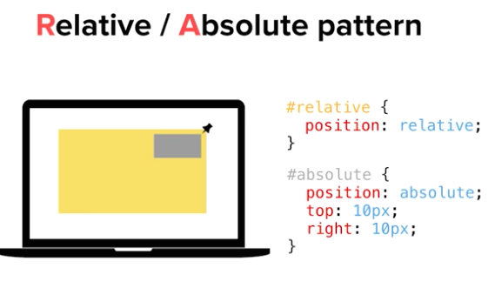

No need to define the width of elements, especially cards, since the width is decided by responsive grid design

1. Badge

use an avatar and a span badge element

1. Flexbox

flex items as children of flexbox

CSS height property: 100vh – viewport height